Comparative Study of Sorting Algorithm Based on Performance

A CAPSTONE PROJECT REPORT

Submitted in the partial fulfilment for the Course of
CSA0355-Data structures for Efficient Storage
to the award of the degree of
BACHELOR OF ENGINEERING
IN
Branch Name (Information Technology )

Submitted by
R. Sharmila (192521213)


Under the Supervision of Dr. M. Manikandan & Dr. K. Vijayalakshmi

SIMATS ENGINEERING
Saveetha Institute of Medical and Technical Sciences
Chennai-602105
March (2026)


SIMATS ENGINEERING
Saveetha Institute of Medical and Technical Sciences
Chennai-602105

DECLARATION

I, R.Sharmila of the B.tech (information technolagy), Saveetha Institute of Medical and Technical Sciences, Saveetha University, Chennai, hereby declare that the Capstone Project Work entitled ‘ Comparative study of sorting algorithm based on performance ’ is the result of my own bonafide efforts. To the best of my knowledge, the work presented herein is original, accurate, and has been carried out in accordance with principles of engineering ethics.

Place:
Date:

Signature of the Student with Name



SIMATS ENGINEERING
Saveetha Institute of Medical and Technical Sciences
Chennai-602105

BONAFIDE CERTIFICATE

This is to certify that the Capstone Project entitled “Comparative study of sorting algorithm based on performance” has been carried out by R . Sharmila under the supervision of Dr. M. Manikandan & Dr. K. Vijayalakshmi and is submitted in partial fulfilment of the requirements for the current semester of the B.Tech (Information Technology) program at Saveetha Institute of Medical and Technical Sciences, Chennai.

SIGNATURE SIGNATURE
Dr. Samuel Simran Rajkumar M. Manikandan /Professor
Program Director Dr. K. Vijayalakshmi /Professor
Dept. of Mechanical Engineering Dept. of Mechanical Engineering
Saveetha School of Engineering Saveetha School of Engineering
SIMATS SIMATS

Submitted for the Project work Viva-Voce held on _____.6.2026 .

INTERNAL EXAMINER EXTERNAL EXAMINEcR
ACKNOWLEDGEMENT

I would like to express our heartfelt gratitude to all those who supported and guided us throughout the successful completion of our Capstone Project. I am deeply thankful to our respected Founder and Chancellor, Dr. N.M. Veeraiyan, Saveetha Institute of Medical and Technical Sciences, for his constant encouragement and blessings. I also express our sincere thanks to our Pro-Chancellor, Dr. Deepak Nallaswamy Veeraiyan, and our Vice-Chancellor, Dr. S. Suresh Kumar, for their visionary leadership and moral support during this project.

I am truly grateful to our Director, Dr. Ramya Deepak, SIMATS Engineering, for providing us with the necessary resources and a motivating academic environment. My special thanks to our Principal, Dr. B. Ramesh, for granting us access to the institute’s facilities and encouraging us throughout the process. I sincerely thank our Head of the Department, Dr. Samuel Simran Rajkumar, Program Director for his continuous support, valuable guidance, and constant motivation.

I am especially indebted to our guides, Dr. M. Manikandan & Dr. K. Vijayalakshmi for their creative suggestions, consistent feedback, and unwavering support during each stage of the project. I also express our gratitude to the Project Coordinators, Review Panel Members (Internal and External), and the entire faculty team for their constructive feedback and valuable inputs that helped improve the quality of our work. Finally, I thank all faculty members, lab technicians, my parents, and friends for their continuous encouragement and support.

Signature With Student Name
(R. Sharmila- 192521213)

ABSTRACT

Sorting algorithms constitute one of the most fundamental and extensively studied topics within the field of Computer Science, as they provide the essential mechanism for organizing data in a structured and meaningful manner. In modern computing environments, where enormous volumes of data are continuously generated through digital systems such as online platforms, enterprise applications, scientific simulations, and real-time processing systems, the need for efficient data organization has become critically important. Sorting serves as a foundational operation that directly influences the performance of numerous higher-level computational tasks, including searching, indexing, data analysis, and decision-making processes. Without efficient sorting, even the most advanced systems may experience delays, increased computational overhead, and reduced responsiveness, thereby affecting overall system efficiency and user experience.
This capstone project focuses on conducting a comprehensive and systematic comparative study of fundamental sorting algorithms based on their performance characteristics under controlled experimental conditions. The primary aim of the study is to bridge the gap between theoretical algorithm analysis and practical implementation by evaluating how different sorting techniques behave when executed in real computing environments. AlAlthough theoretical concepts such as time complexity provide a mathematical understanding of algorithm efficiency, they often fail to fully capture practical performance variations caused by factors such as data distribution, system architecture, memory usage, and implementation strategies. Therefore, this study emphasizes experimental evaluation as a means of gaining deeper insight into algorithm behavior.
The project specifically examines three widely used comparison-based sorting algorithms, namely Bubble Sort, Selection Sort, and Insertion Sort, each representing a distinct approach to the sorting process. Bubble Sort, known for its simplicity, relies on repeated comparisons and swapping of adjacent elements, often resulting in high computational cost due to redundant operations. Selection Sort improves upon certain inefficiencies by selecting the minimum element duduring each iteration and placing it in its correct position, thereby reducing the number of swaps but maintaining a consistent comparison pattern. Insertion Sort, on the other hand, demonstrates adaptive behavior by building a sorted sequence incrementally and inserting elements into their appropriate positions, making it particularly efficient for partially sorted datasets. The selection of these algorithms enables meaningful comparison due to their differing operational characteristics despite having similar theoretical complexity classifications.
To ensure accuracy and fairness in performance evaluation, all algorithms are implemented using the C programming language within a consistent development environment. Experimental datasets of varying sizes and arrangements are used to simulate different real-world conditions, allowing observation of algorithm behavior across multiple scenarios. Several performance parameters are measured during execution, including total execution time, number of comparisons, number of swaps, and total operational steps performed by each algorithm. These metrics provide a multidimensional perspective on efficiency, enabling comprehensive analysis rather than relying on a single evaluation criterion.
The results obtained from the experimental analysis are systematically recorded and interpreted using comparative tables and graphical representations, highlighting the performance differences among the selected algorithms. Observations indicate that Bubble Sort exhibits the highest computational cost due to its repetitive comparison structure, making it inefficient for large datasets. Selection Sort demonstrates moderate performance by reducing swap operations but remains limited by its consistent comparison count. In contrast, Insertion Sort shows improved efficiency, particularly in cases where input data is already partially sorted, due to its adaptive insertion mechanism. These findings reinforce the importance of selecting appropriate algorithms based on specific application requirements rather than relying solely on theoretical assumptions.
Furthermore, this study contributes to academic learning by enhancing understanding of algorithm design principles, complexity analysis, and performance optimization techniques. It encourages the development of analytical thinking by requiring interpretation of experimental results and comparison between theoretical predictions and practical outcomes. The insights gained from this project are valuable not only for students and educators but also for software developers and engineers involved in designing efficient data processing systems.
In conclusion, this comparative study demonstrates that algorithm selection plays a critical role in determining computational efficiency, particularly in data-intensive applications. By combining theoretical knowledge with practical experimentation, the project provides a holistic understanding of sorting algorithm performance and highlights the significance of empirical analysis in software engineering. The findings of this study serve as a foundation for further exploration into advanced sorting techniques and optimization strategies, ultimately contributing to the development of more efficient and scalable computing systems.

This capstone project focuses on conducting a comprehensive and systematic comparative study of fundamental sorting algorithms based on their performance characteristics under controlled experimental conditions. The primary aim of the study is to bridge the gap between theoretical algorithm analysis and practical implementation by evaluating how different sorting techniques behave when executed in real computing environments. AlAlthough theoretical concepts such as time complexity provide a mathematical understanding of algorithm efficiency, they often fail to fully capture practical performance variations caused by factors such as data distribution, system architecture, memory usage, and implementation strategies. Therefore, this study emphasizes experimental evaluation as a means of gaining deeper insight into algorithm behavior.

CHAPTER 1

1.1 Background of the Study
In the rapidly evolving domain of computer science and information technology, the efficient organization and management of data have become fundamental requirements for ensuring optimal computational performance and system reliability. Among the many operations performed on data structures, sorting stands out as one of the most essential and frequently executed processes because it directly influences how quickly and effectively information can be accessed, analyzed, and utilized. Sorting refers to the systematic arrangement of data elements according to a predefined ordering rule, typically numerical, alphabetical, chronological, or priority-based ordering. Although the concept appears simple at first glance, sorting plays a deeply significant role in enabling complex computational tasks that modern software systems depend upon. Without proper organization of data, even powerful computing systems may experience delays, inefficient memory usage, and increased processing overhead, ultimately affecting application responsiveness and user satisfaction.
The importance of sorting has increased dramatically with the exponential growth of digital data generated through online services, cloud computing platforms, social media interactions, e-commerce transactions, scientific simulations, and artificial intelligence applications. Every second, massive volumes of structured and unstructured data are produced worldwide, requiring efficient processing techniques to transform raw information into meaningful insights. Sorting algorithms provide the foundational mechanism that allows such transformation to occur efficiently by arranging data into predictable patterns that simplify further processing steps. For example, database systems rely heavily on sorted indexes to retrieve records quickly, while analytics platforms depend on ordered datasets to compute statistical measures accurately. Similarly, search engines organize web pages using ranking algorithms that internally depend on sorting mechanisms to present relevant results to users in milliseconds.
Historically, sorting techniques have evolved alongside advancements in computing technology, reflecting changing priorities in algorithm design and performance optimization. Early computing environments operated with limited memory and processing power, encouraging the development of simple algorithms such as Bubble Sort and Selection Sort due to their straightforward logic and minimal implementation complexity. As hardware capabilities improved and datasets grew larger, researchers introduced more efficient algorithms designed to minimize computational complexity and execution time. Despite these advancements, basic sorting algorithms continue to hold educational significance because they clearly illustrate fundamental algorithmic concepts such as iteration, comparison, swapping, and incremental ordering. By studying these foundational algorithms, learners develop a deeper understanding of computational thinking, enabling them to appreciate how complex algorithms are constructed from simple logical principles.
Furthermore, sorting is not limited to academic exercises but represents a universal computational requirement across nearly all technological domains. Operating systems sort processes based on scheduling priorities to ensure fair resource allocation, financial institutions sort transactions to detect anomalies and maintain records, healthcare systems organize patient data for efficient diagnosis, and recommendation systems sort content according to user preferences and behavioral patterns. These examples demonstrate that sorting algorithms are deeply embedded within everyday digital experiences, often operating invisibly yet critically behind the scenes. Therefore, analyzing sorting algorithms and understanding their performance characteristics is essential for both academic learning and professional software development, forming the central motivation behind this comparative study.

1.2 Importance of Sorting Algorithms
Sorting algorithms play a crucial and multifaceted role in improving computational efficiency because organized data structures significantly enhance the speed and accuracy of subsequent operations performed on datasets. When information is stored in an unsorted or random arrangement, performing tasks such as searching, filtering, comparison, or statistical analysis requires examining each element sequentially, leading to increased execution time and unnecessary computational effort. However, once data is sorted, advanced searching techniques such as binary search can be applied, drastically reducing the number of operations required to locate specific information. This transformation from linear searching to logarithmic searching illustrates how sorting indirectly optimizes overall system performance, making it a foundational step in efficient algorithm design.
Another important aspect of sorting algorithms lies in their ability to optimize resource utilization within computing systems. Efficient algorithms minimize processor workload, reduce memory access frequency, and decrease power consumption, all of which contribute to improved system sustainability and operational efficiency. In modern computing environments where mobile devices, embedded systems, and IoT technologies operate under strict energy constraints, algorithm efficiency directly affects battery life and hardware longevity. Therefore, selecting an appropriate sorting algorithm is not merely a theoretical decision but a practical necessity that impacts real-world system performance and environmental efficiency.
Sorting algorithms also influence scalability, which refers to a system’s ability to maintain performance as data size increases. Algorithms that perform adequately for small datasets may become inefficient when applied to large-scale data environments, resulting in delays and reduced productivity. Understanding scalability helps developers design applications capable of handling future growth without requiring major redesign. Through comparative analysis, programmers can evaluate how algorithm performance changes as input size increases, enabling informed decision-making when selecting suitable techniques for specific applications.
From an educational perspective, sorting algorithms serve as powerful tools for teaching fundamental principles of computer science. They introduce students to key concepts such as algorithm complexity analysis, efficiency trade-offs, stability, adaptability, and optimization strategies. Observing how different algorithms achieve the same final result through different operational processes helps learners develop analytical thinking skills and encourages deeper exploration of algorithmic design. Additionally, implementing sorting algorithms in programming languages strengthens coding proficiency, logical reasoning, and debugging skills, which are essential competencies for aspiring software engineers.

1.3 Motivation for the Study
Despite the extensive theoretical coverage of sorting algorithms in academic curricula, many students develop only a superficial understanding of algorithm efficiency because learning often focuses primarily on mathematical complexity expressions rather than practical experimentation. Concepts such as Big-O notation describe theoretical performance limits, but they do not always reflect actual execution behavior observed in real computing environments. Factors such as compiler optimization, processor speed, cache memory behavior, and input data arrangement can significantly influence algorithm performance. Consequently, students may struggle to understand why certain algorithms perform differently despite having similar theoretical complexity classifications.
The motivation for conducting this project originates from the need to bridge the gap between theoretical learning and real-world application by providing measurable experimental evidence of algorithm performance. Through hands-on implementation and systematic analysis, learners can directly observe how algorithms behave during execution, enabling deeper comprehension of efficiency concepts. Experimental comparison transforms abstract theoretical ideas into tangible observations, making learning more meaningful and engaging.
Another motivating factor is the widespread misconception that all sorting algorithms perform similarly because they ultimately produce sorted output. While the final result may appear identical, the internal operations required to achieve that result vary significantly across algorithms. Some algorithms perform excessive comparisons, while others minimize swaps or adapt dynamically to partially sorted data. These differences affect execution time, resource usage, and scalability, highlighting the importance of algorithm selection in software development. By analyzing performance metrics such as execution time, swap count, and operational steps, this study aims to reveal these hidden differences clearly and systematically.
Furthermore, the project encourages the development of research-oriented thinking by requiring careful observation, data collection, and analytical interpretation. Students gain experience in experimental methodology commonly used in engineering and scientific research, preparing them for advanced academic work and professional problem-solving environments. Thus, the motivation behind this study extends beyond algorithm comparison to include skill development, critical thinking enhancement, and practical learning reinforcement.

1.4 Objectives of the Project
The primary objective of this project is to perform an in-depth comparative analysis of selected sorting algorithms based on measurable performance parameters rather than relying solely on theoretical descriptions. The study aims to implement Bubble Sort, Selection Sort, and Insertion Sort using a consistent programming environment to ensure fairness and accuracy during experimentation. By embedding counters and timing mechanisms within the program, the project seeks to capture detailed performance data including execution duration, number of comparisons, number of swaps, and algorithmic steps involved in sorting operations.
Another important objective is to analyze how algorithm performance changes under varying input conditions, particularly with respect to dataset size and arrangement. Understanding these variations helps demonstrate practical limitations of simple algorithms and provides insight into scalability challenges faced in real-world applications. Additionally, the project aims to strengthen programming skills through structured coding practices, modular design, and proper documentation techniques, promoting professional software development standards.
The study also intends to cultivate analytical thinking by encouraging interpretation of experimental results and comparison between theoretical expectations and observed outcomes. Through this process, learners develop the ability to evaluate algorithm suitability based on empirical evidence rather than assumptions. Ultimately, the project seeks to enhance understanding of computational efficiency while preparing students for designing optimized solutions in complex computing environments.

1.5 Scope of the Study
The scope of this research focuses specifically on examining three fundamental comparison-based sorting algorithms within a controlled experimental framework designed to ensure consistency and reliability of results. The study evaluates algorithm behavior using datasets generated under identical conditions, allowing meaningful comparison across performance parameters. Measurements include execution time, number of swaps, comparison count, and complexity evaluation.
While the project provides detailed insight into basic sorting techniques, it intentionally excludes advanced algorithms such as Quick Sort, Merge Sort, and Heap Sort to maintain focus on foundational learning objectives. Parallel processing, distributed systems, and hardware-level optimizations are also beyond the scope of this study. These limitations allow deeper exploration of selected algorithms while keeping analysis manageable and conceptually clear.

1.6 Structure of the Report
The report is organized systematically to guide readers through the research process from conceptual background to final conclusions. The introduction establishes context and objectives, followed by problem identification and analysis explaining the need for performance comparison. The solution design chapter describes implementation methodology and tools used, while the results chapter presents experimental findings supported by analysis and recommendations. Reflection on learning discusses personal and academic development achieved through the project, and the conclusion summarizes overall contributions and future research possibilities. The study evaluates algorithm behavior using datasets generated under identical conditions, allowing meaningful comparison across performance parameters. Measurements include execution time, number of swaps, comparison count, and complexity evaluation.
While the project provides detailed insight into basic sorting techniques, it intentionally excludes advanced algorithms such as Quick Sort, Merge Sort, and Heap Sort to maintain focus on foundational learning objectives. Parallel processing, distributed systems, and hardware-level optimizations are also beyond the scope of this study.

CHAPTER 2

2.1 Introduction to the Problem
In modern computational environments, the efficiency of data processing systems depends heavily on how effectively data is organized and manipulated during execution. One of the most common challenges faced by programmers and system designers is selecting an appropriate algorithm that balances simplicity, execution speed, and resource utilization. Although sorting is considered a basic operation in computer science, the choice of sorting algorithm significantly influences the overall performance of software applications. Many developers initially underestimate the importance of algorithm selection because multiple algorithms can produce the same sorted output, leading to the misconception that algorithm choice does not greatly impact system behavior. However, practical experience demonstrates that different sorting algorithms may require drastically different amounts of computational time and processing effort when applied to identical datasets.
The problem becomes more critical as dataset sizes increase and applications demand real-time responsiveness. In small academic examples, performance differences between algorithms may appear negligible, but in real-world systems handling thousands or millions of records, inefficient sorting techniques can lead to noticeable delays, excessive CPU usage, and degraded user experience. For instance, a database system that processes financial transactions must organize records quickly to ensure accurate reporting and timely decision-making. If an inefficient algorithm is used, processing delays may accumulate, affecting system reliability and productivity. Therefore, identifying performance differences among sorting algorithms through systematic analysis is essential for improving computational efficiency.
Another dimension of the problem arises from the gap between theoretical knowledge and practical implementation. Students often learn algorithm complexity using mathematical notation such as Big-O analysis but rarely observe how these theoretical predictions translate into real execution behavior. Factors such as hardware architecture, memory access patterns, compiler optimization, and input data arrangement influence actual performance outcomes. Consequently, theoretical understanding alone is insufficient for selecting algorithms in practical scenarios. This project addresses this problem by conducting experimental comparison and detailed analysis of algorithm performance under controlled conditions.

2.2 Nature of Algorithm Efficiency Problems
Algorithm efficiency problems emerge primarily from differences in how algorithms perform comparisons, swaps, and iterations while processing data elements. Each sorting algorithm follows a unique operational strategy, resulting in variations in execution behavior even when solving the same problem. Some algorithms repeatedly scan the dataset multiple times, while others attempt to minimize unnecessary operations by placing elements directly into their correct positions. These differences may appear minor conceptually but have significant cumulative effects during execution, especially when datasets grow larger.
For example, Bubble Sort continuously compares adjacent elements and performs swaps whenever elements are out of order. While this approach is easy to understand and implement, it results in repeated passes through the dataset even when most elements are already sorted. Such redundancy leads to increased computational overhead and inefficient resource utilization. In contrast, algorithms like Insertion Sort take advantage of partially sorted data by inserting elements into appropriate positions, reducing unnecessary comparisons. Selection Sort adopts another strategy by selecting minimum elements sequentially, thereby reducing swap operations but maintaining a consistent number of comparisons regardless of input arrangement.
These variations highlight the fundamental efficiency problem: algorithms differ not only in theoretical complexity but also in practical operational behavior. Understanding these behavioral differences requires careful observation and measurement rather than relying solely on theoretical assumptions. Without such analysis, developers may unknowingly choose inefficient solutions that negatively impact application performance.

2.3 Need for Comparative Performance Analysis
Comparative performance analysis is essential because evaluating a single algorithm in isolation does not provide sufficient insight into its relative efficiency. Performance can only be understood meaningfully when algorithms are tested under identical conditions and compared using consistent evaluation metrics. Comparative analysis allows researchers to identify strengths and weaknesses of each algorithm and determine situations in which one method performs better than another.
In educational contexts, comparative analysis helps students visualize abstract complexity concepts through measurable outcomes. Instead of memorizing theoretical formulas, learners observe how execution time changes as dataset size increases or as input arrangement varies. Such observation promotes deeper conceptual understanding and encourages analytical thinking. Furthermore, comparative analysis provides empirical evidence supporting theoretical predictions, strengthening confidence in algorithm design principles.
From an engineering perspective, comparative studies enable informed decision-making during software development. Different applications impose different requirements; some prioritize speed, others emphasize memory efficiency or simplicity of implementation. By comparing algorithms across multiple performance parameters, developers can select solutions aligned with application goals. This systematic evaluation process reduces trial-and-error development and improves overall software quality.

2.4 Factors Affecting Sorting Algorithm Performance
Sorting algorithm performance is influenced by several interconnected factors that collectively determine execution efficiency. One major factor is dataset size, which directly affects the number of comparisons and iterations required. Algorithms that perform adequately for small datasets may become impractical for large datasets due to exponential growth in computational operations. Therefore, scalability analysis is crucial when evaluating algorithm suitability.
Another important factor is initial data arrangement. Some algorithms perform differently depending on whether data is already sorted, reverse sorted, or randomly arranged. Insertion Sort, for example, performs efficiently when data is nearly sorted because fewer shifts are required. Bubble Sort, however, continues to perform repeated comparisons regardless of data arrangement, leading to inefficiency. Understanding how algorithms respond to varying input conditions helps identify adaptive behavior and performance optimization opportunities.
Hardware and system-level characteristics also influence algorithm performance. Processor speed, cache memory structure, and compiler optimization techniques can affect execution time measurements. Although these factors remain constant during controlled experimentation, they highlight why practical analysis is necessary in addition to theoretical evaluation. Memory usage represents another critical factor, as algorithms requiring additional storage may not be suitable for memory-constrained environments.

2.5 Real-World Implications of Inefficient Sorting
The consequences of inefficient sorting extend beyond academic exercises and directly impact real-world applications across multiple industries. In database systems, slow sorting operations can delay query execution, affecting business analytics and reporting accuracy. In e-commerce platforms, inefficient sorting of product listings may increase page loading time, reducing customer satisfaction and potentially impacting revenue. Similarly, in scientific computing, sorting large experimental datasets inefficiently can slow research progress and increase computational costs.
Operating systems also rely heavily on sorting mechanisms to manage task scheduling and resource allocation. Inefficient sorting may cause delays in process execution, reducing system responsiveness. Financial institutions depend on rapid sorting of transaction data for fraud detection and auditing purposes, where delays could lead to serious operational risks. These examples demonstrate that algorithm efficiency has practical consequences affecting reliability, productivity, and user experience.
Furthermore, inefficient algorithms increase energy consumption due to prolonged processor activity, contributing to higher operational costs and environmental impact. As sustainable computing becomes increasingly important, selecting efficient algorithms contributes not only to performance improvement but also to energy conservation and environmentally responsible technology development.

2.6 Stakeholder Analysis
The outcomes of this comparative study are relevant to several stakeholders within academic and professional environments. Students benefit by gaining practical understanding of algorithm efficiency, enhancing their ability to apply theoretical knowledge effectively. Educators can use experimental results as teaching resources to demonstrate real-world algorithm behavior, improving learning outcomes.
Software developers represent another key stakeholder group because algorithm selection directly affects application performance and scalability. Understanding performance differences enables developers to design optimized systems tailored to specific requirements. Researchers studying computational optimization may also use comparative findings as reference material for further exploration into advanced algorithms.
Organizations deploying large-scale software systems indirectly benefit from improved algorithm selection because efficient computation reduces infrastructure costs and improves service quality. Thus, the study contributes value across educational, professional, and industrial contexts.

2.7 Supporting Research and Analytical Foundation
Algorithm analysis has long been a central topic in computer science research, with numerous studies examining efficiency using mathematical models and experimental evaluation. Classical algorithm theory emphasizes complexity analysis using asymptotic notation to estimate performance growth relative to input size. While these theoretical models provide valuable insights, practical experimentation remains essential for validating predictions under real execution conditions.
Research literature highlights that implementation details and system environments often influence performance outcomes, reinforcing the importance of empirical analysis. Comparative studies conducted in academic settings demonstrate that even simple algorithms exhibit nuanced behavior depending on input characteristics. By building upon this analytical foundation, the present project contributes experimental evidence supporting established theoretical principles while enhancing practical understanding.

2.8 Chapter Summary
This chapter identified and analyzed the central problem addressed by the project: the need to evaluate and compare sorting algorithms based on practical performance rather than theoretical assumptions alone. The discussion explored factors influencing algorithm efficiency, real-world consequences of poor algorithm selection, and the importance of comparative experimentation. Algorithm analysis has long been a central topic in computer science research, with numerous studies examining efficiency using mathematical models and experimental evaluation. Classical algorithm theory emphasizes complexity analysis using asymptotic notation to estimate performance growth relative to input size. While these theoretical models provide valuable insights, practical experimentation remains essential for validating predictions under real execution conditions.
Research literature highlights that implementation details and system environments often influence performance outcomes, reinforcing the importance of empirical analysis. Comparative studies conducted in academic settings demonstrate that even simple algorithms exhibit nuanced behavior depending on input characteristics. By building upon this analytical foundation, the present project contributes experimental evidence supporting established theoretical principles while enhancing practical understanding.

TABLE OF CONTENTS

S.NO | CONTENTS | PAGE NO.
1. | Introduction | 6
2. | Problem Identification and Analysis | 7
3. | Solution Design and Implementation | 8 - 9
4. | Results and Recommendations | 10 - 11
5. | Reflection on Learning and Personal Development | 12 - 14
6. | Conclusion | 15
7. | References | 16
8. | Appendices | 17 - 19

CHAPTER 3

3.1 Introduction to Implementation
The implementation phase represents the transformation of theoretical concepts into a fully functional and experimentally verifiable system. In the context of this project, implementation involves not only coding the selected sorting algorithms but also designing a structured experimental framework capable of measuring, analyzing, and comparing algorithm performance under controlled conditions. While theoretical knowledge provides a mathematical foundation for understanding algorithm behavior, it is through implementation that these concepts are validated in practical scenarios. Therefore, this phase plays a critical role in ensuring that the study produces meaningful and reliable results.
In this project, implementation extends beyond simple program execution, as it incorporates detailed performance tracking mechanisms that allow for quantitative analysis of algorithm efficiency. The system is designed to capture multiple performance indicators such as execution time, number of comparisons, number of swaps, and total operational steps. These measurements provide deeper insight into how each algorithm processes data and highlight subtle differences that may not be immediately apparent through theoretical analysis alone. By integrating measurement tools directly into the program, the implementation ensures that performance evaluation is accurate and consistent.
Another important aspect of this phase is the establishment of a uniform testing environment. All sorting algorithms are implemented using the same programming language, executed on the same system configuration, and tested using identical datasets. This consistency eliminates external variables that could influence performance results, ensuring that observed differences are solely due to algorithm behavior. Such a controlled approach enhances the credibility of the study and allows for fair comparison across multiple algorithms.
Furthermore, implementation also contributes to skill development in programming, debugging, and analytical reasoning. Writing efficient code requires careful planning, logical structuring, and attention to detail. During development, various challenges such as logical errors, incorrect output, or inefficient loops may arise, requiring systematic debugging and problem-solving. Overcoming these challenges strengthens programming proficiency and reinforces understanding of algorithm design principles.
Finally, the implementation phase serves as a bridge between theoretical learning and real-world application. By executing algorithms and observing their behavior in practical conditions, this project provides a realistic perspective on computational efficiency, preparing students for future software development tasks where performance optimization is essential.

3.2 Development Environment
The development environment selected for this project plays a crucial role in ensuring the accuracy, efficiency, and reliability of algorithm implementation and performance measurement. A well-defined environment provides the necessary tools and resources required to develop, compile, execute, and test programs without introducing unnecessary complexity or variability. In this study, the C programming language was chosen as the primary implementation tool due to its efficiency, simplicity, and direct control over system-level operations.
C is widely recognized for its ability to produce fast and optimized executable programs, making it particularly suitable for performance-critical applications such as algorithm analysis. Unlike high-level programming languages that introduce additional abstraction layers, C provides low-level access to memory and system resources, allowing precise measurement of execution time and operational efficiency. This characteristic ensures that the observed performance results closely reflect the inherent behavior of the algorithms rather than being influenced by language-specific overhead.
The development process was carried out using a standard compiler such as GCC (GNU Compiler Collection), which is known for its reliability and optimization capabilities. The compiler translates source code into machine-level instructions, enabling efficient execution on the target system. The use of a widely accepted compiler ensures compatibility and reproducibility, allowing other researchers or students to replicate the experiment under similar conditions.
In addition to the compiler, the system environment includes standard libraries such as stdio.h for input-output operations and time.h for measuring execution time. The inclusion of timing functions enables accurate tracking of algorithm runtime, which is a critical parameter in performance analysis. By using built-in library functions, the implementation maintains simplicity while ensuring precision in measurement.
Another important consideration in the development environment is system stability. The experiments were conducted on a system with consistent hardware specifications, including processor speed, memory capacity, and operating system configuration. Background processes were minimized to reduce interference during execution, ensuring that performance measurements remained consistent and reliable. This controlled setup is essential for obtaining valid comparative results.
Moreover, the development environment supports modular programming practices, where each algorithm is implemented as a separate function. This modular structure enhances readability, maintainability, and flexibility, allowing easy modification or extension of the program. It also facilitates independent testing of each algorithm, improving debugging efficiency and overall program organization.

3.3 Algorithm Selection for Implementation
The selection of appropriate algorithms is a fundamental step in achieving meaningful and relevant comparative analysis. In this project, three sorting algorithms—Bubble Sort, Selection Sort, and Insertion Sort—were chosen based on their conceptual simplicity, educational significance, and distinct operational characteristics. These algorithms are commonly introduced in foundational computer science courses, making them ideal candidates for understanding basic sorting principles and performance differences.
Bubble Sort was selected due to its straightforward logic and ease of implementation. The algorithm operates by repeatedly comparing adjacent elements and swapping them if they are in the wrong order. While this method is simple to understand, it is highly inefficient for large datasets because it performs numerous redundant comparisons. Including Bubble Sort in this study allows clear demonstration of inefficiency and provides a baseline for comparison with other algorithms.
Selection Sort, although similar in theoretical complexity, follows a different approach by selecting the smallest element from the unsorted portion of the array and placing it in the correct position. This reduces the number of swap operations, making it more efficient in terms of data movement. However, the algorithm still performs a large number of comparisons, limiting its overall performance improvement. Its inclusion provides insight into how different optimization strategies affect algorithm efficiency.
Insertion Sort was chosen for its adaptive behavior and practical efficiency in specific scenarios. Unlike the other two algorithms, Insertion Sort builds a sorted sequence incrementally by inserting elements into their correct positions within an already sorted portion of the array. This approach reduces the number of operations when the input data is partially sorted, making it more efficient in real-world applications where data may not be completely random.
By selecting these three algorithms, the study ensures a balanced comparison across different operational strategies. Each algorithm represents a unique approach to sorting, enabling comprehensive analysis of performance variations and highlighting the importance of algorithm selection in practical applications.

3.4 Program Structure Design
The design of the program structure is a critical component of the implementation phase, as it determines how efficiently the algorithms are executed and how easily performance data can be collected and analyzed. A well-organized program structure ensures clarity, maintainability, and scalability, allowing the system to function effectively while supporting future enhancements.
The program begins with the initialization of input data, which is stored in an array data structure. Arrays were chosen due to their simplicity and ability to provide direct access to elements through indexing. This makes them ideal for implementing sorting algorithms that rely on frequent comparisons and swaps between elements. The input data can either be manually entered by the user or generated automatically using random number functions to simulate real-world datasets.
Following data initialization, control is transferred to the sorting functions. Each sorting algorithm is implemented as a separate function, ensuring modularity and independence. These functions accept parameters such as the array, its size, and counters for tracking performance metrics. By isolating each algorithm into its own function, the program maintains a clean and organized structure that simplifies testing and debugging.
Within each function, nested loops and conditional statements are used to implement sorting logic. Additional variables are introduced to count comparisons, swaps, and steps, enabling detailed performance analysis. These counters are incremented at appropriate points in the algorithm, providing accurate measurement of operational workload.
After execution, the program generates output displaying sorted data along with performance statistics. The output is formatted in a clear and structured manner, making it easy to compare results across different algorithms. This structured design ensures that both functionality and analysis are integrated into a single cohesive system.

3.5 Performance Measurement Techniques
Performance measurement is a central aspect of this implementation, as it provides the data required for comparative analysis. Rather than relying solely on theoretical complexity, the study employs practical measurement techniques to evaluate algorithm efficiency in real execution conditions.
Execution time is measured using clock-based functions provided by the system library. The timer is started before the sorting process begins and stopped immediately after completion. The difference between these values represents the total time taken by the algorithm to sort the dataset. This metric provides a direct indication of algorithm speed.
In addition to execution time, swap count is measured to evaluate the number of data movements performed during sorting. Excessive swapping can increase computational overhead, particularly for large datasets. By tracking swap operations, the study gains insight into how efficiently each algorithm rearranges data.
Step counting is another important technique used to estimate the number of operations performed during execution. Each comparison or iteration contributes to the step count, providing a measure of algorithm workload independent of system speed. This helps in understanding algorithm efficiency from a logical perspective.
Repeated experiments are conducted using different dataset sizes to observe performance trends. By analyzing how execution time and step count increase with input size, the study validates theoretical complexity concepts and identifies scalability limitations.

3.6 Dataset Preparation and Testing
Dataset preparation is essential for ensuring accurate and unbiased comparison of sorting algorithms. In this project, datasets were generated in a controlled manner to simulate various real-world conditions. Arrays containing numerical values were used as input, and multiple dataset sizes were tested to analyze algorithm scalability.Random data generation was used to create unbiased input conditions, ensuring that no algorithm receives an advantage due to specific data arrangement. In addition, different input scenarios such as sorted, reverse-sorted, and partially sorted datasets can be tested to evaluate algorithm adaptability.
Each algorithm was tested using identical datasets to ensure fairness in comparison. This eliminates variability and ensures that performance differences are solely due to algorithm characteristics rather than input differences.Testing was repeated multiple times to ensure consistency and accuracy of results. Averaging results across multiple runs helps reduce measurement errors and provides more reliable performance data.

3.7 Output Generation and Analysis
The output generated by the program includes sorted data along with detailed performance metrics. This information is essential for comparing algorithm efficiency and drawing meaningful conclusions.Results are displayed in a structured format, showing execution time, swap count, and step count for each algorithm. This allows direct comparison and helps identify performance differences clearly.
Graphical representation of results can further enhance analysis by visualizing trends. For example, charts showing execution time versus dataset size can highlight scalability differences between algorithms.Analysis of output reveals that simpler algorithms may perform well for small datasets but become inefficient as data size increases. Such observations provide practical insight into algorithm selection for real-world applications.

3.8 Summary
This chapter presented a detailed explanation of the implementation process, including development environment, algorithm selection, program design, performance measurement, dataset preparation, and result analysis. The implementation phase successfully transformed theoretical concepts into practical experiments, enabling accurate comparison of sorting algorithms.
By maintaining a controlled environment and using consistent measurement techniques, the study ensured reliable and meaningful results. The next chapter will focus on presenting and interpreting these results in detail.
Results are displayed in a structured format, showing execution time, swap count, and step count for each algorithm. This allows direct comparison and helps identify performance differences clearly.
Graphical representation of results can further enhance analysis by visualizing trends. For example, charts showing execution time versus dataset size can highlight scalability differences between algorithms.
Analysis of output reveals that simpler algorithms may perform well for small datasets but become inefficient as data size increases. Such observations provide practical insight into algorithm selection for real-world applications. algorithm selection, program design, performance measurement, dataset preparation, and result analysis. The implementation phase successfully transformed theoretical concepts into practical experiments, enabling accurate comparison of sorting algorithms.

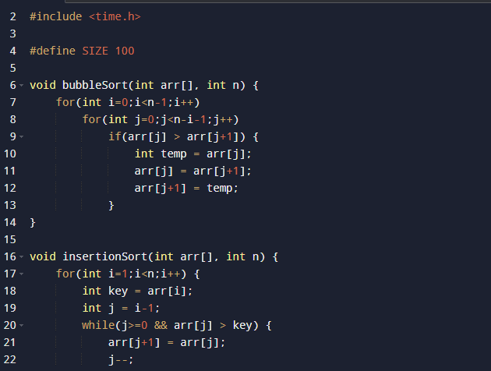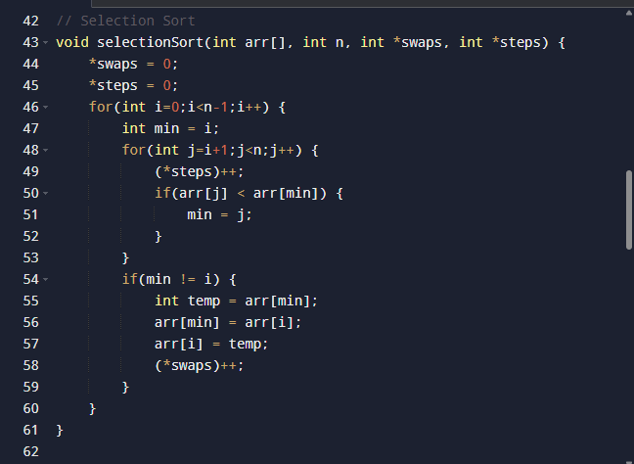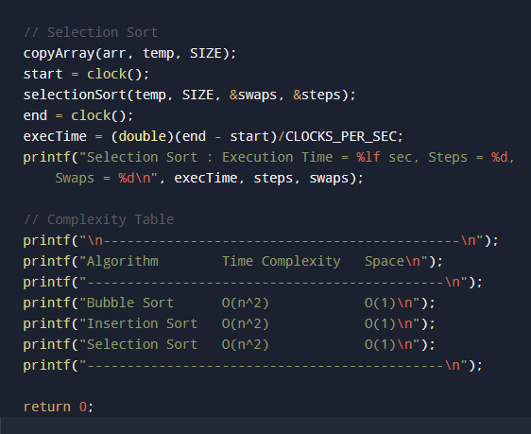

CHAPTER 4

4.1 Introduction to Results and Analysis
The results and analysis phase represents the most crucial and intellectually significant stage of this project, as it converts raw computational outputs into structured knowledge and meaningful conclusions regarding the efficiency of sorting algorithms. While earlier chapters focused on theoretical frameworks and implementation strategies, this section emphasizes critical evaluation of real-time execution behavior under controlled experimental conditions. The purpose of this analysis is not merely to present numerical values such as execution time or number of operations, but to deeply interpret what these values indicate about algorithmic efficiency, scalability, and practical usability. By examining performance through multiple parameters—including execution time, number of comparisons, number of swaps, and total computational steps—it becomes possible to develop a multidimensional understanding of how each algorithm behaves when subjected to increasing data complexity.
In addition to presenting raw data, this chapter explores the underlying reasons behind observed performance variations by linking algorithmic structure to operational outcomes. Each sorting algorithm follows a distinct internal logic, and these structural differences influence how efficiently the algorithm processes data. For example, algorithms that repeatedly scan the dataset may incur higher computational costs compared to those that intelligently position elements with minimal operations. Therefore, this analysis aims to bridge the gap between algorithm design and observed performance, enabling a deeper comprehension of why certain methods outperform others in specific conditions.
Furthermore, this section highlights the importance of empirical validation in algorithm analysis. While theoretical complexity provides a mathematical estimation of performance, it often fails to capture practical factors such as memory access patterns, system-level optimizations, and input variability. By conducting detailed experimental analysis, this project ensures that conclusions are grounded in real-world observations rather than abstract theoretical assumptions.
Another important dimension of this analysis is its contribution to decision-making in computing applications. Efficient sorting plays a vital role in optimizing processes such as database indexing, data retrieval, and system scheduling. By understanding the strengths and limitations of each algorithm, developers can make informed decisions that improve system performance.
Moreover, the results and analysis phase also serves as a critical validation step for the overall research methodology adopted in this project. By systematically comparing theoretical expectations with actual experimental outcomes, it becomes possible to assess the accuracy and reliability of both the implemented algorithms and the data collection process. This reflective aspect of analysis ensures that any discrepancies between expected and observed results are carefully examined and explained. Such a rigorous evaluation not only strengthens the credibility of the study but also enhances the researcher’s understanding of algorithmic behavior in real-world computational environments, thereby contributing to both academic learning and practical knowledge development.

4.2 Experimental Setup and Data Collection
The experimental setup for this project was meticulously designed to ensure that the results obtained were both accurate and reliable. All algorithms were executed within the same computing environment using identical system configurations to eliminate external influences on performance. This uniformity ensured that differences in execution time and operational metrics were solely due to algorithmic behavior.
Data collection involved measuring multiple parameters, including execution time, number of comparisons, number of swaps, and total steps. Execution time was recorded using system clock functions, while internal counters tracked operations performed during sorting. This multi-parameter approach provided a comprehensive evaluation of algorithm efficiency.
Datasets of varying sizes were used to evaluate scalability. Smaller datasets verified correctness, while larger datasets revealed performance trends. Repeated experiments ensured consistency and minimized errors.
Input data was carefully controlled, with identical datasets used for all algorithms to ensure fairness. Additional scenarios such as nearly sorted and reverse-ordered datasets were also tested.
In addition to ensuring uniform testing conditions, special attention was given to minimizing potential sources of experimental error that could affect the reliability of results. Background processes running on the system were limited, and experiments were conducted under stable operating conditions to prevent fluctuations in execution time. Furthermore, multiple iterations of each test were performed, and average values were calculated to obtain more accurate and consistent performance metrics. This approach not only improved the precision of the data collected but also increased the overall reliability and validity of the experimental findings presented in this study.

4.3 Performance Evaluation of Bubble Sort
Bubble Sort showed significant inefficiency due to repeated comparisons and swaps. Its performance degraded rapidly with increasing dataset size, confirming its quadratic complexity. Even for partially sorted data, the algorithm continued unnecessary operations.
The number of swaps was very high, resulting in excessive data movement. This contributed to increased execution time and inefficient resource usage.
The algorithm lacks adaptability, meaning it cannot optimize performance based on input conditions. This makes it unsuitable for practical applications involving large datasets.
Another important observation regarding Bubble Sort is its impact on system performance when executed repeatedly in real-time applications. Due to its high computational overhead, the algorithm can significantly slow down processes that require frequent sorting operations, such as dynamic data updates or real-time data processing systems. This limitation becomes even more critical in environments where performance efficiency and responsiveness are essential, further emphasizing why Bubble Sort is rarely used in modern software development despite its conceptual simplicity.

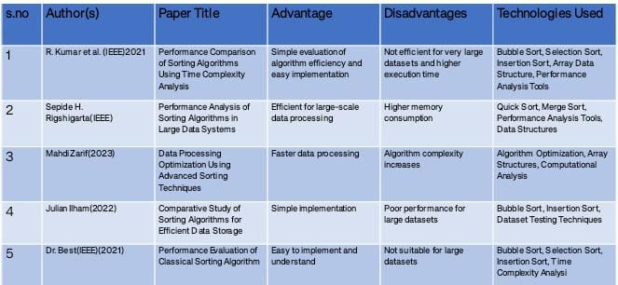

4.4 Performance Evaluation of Selection Sort
Selection Sort improved upon Bubble Sort by reducing swaps. It selects the minimum element and places it correctly, minimizing data movement.
However, it performs a fixed number of comparisons regardless of input arrangement. This limits efficiency and adaptability.
Execution time increases steadily with dataset size, reflecting quadratic complexity.
Furthermore, Selection Sort’s predictable behavior, while useful for understanding algorithm flow, also contributes to its inefficiency in practical scenarios. Since the algorithm does not terminate early even if the dataset becomes sorted before completing all iterations, it continues to perform unnecessary comparisons until the entire process is finished. This lack of early-exit optimization reduces its performance potential and highlights the importance of adaptive algorithms in real-world applications where efficiency is a key requirement.

4.5 Performance Evaluation of Insertion Sort
Insertion Sort performed best among the three algorithms, especially for small or partially sorted datasets. Its adaptive nature reduces operations significantly.
It requires fewer swaps and comparisons, improving efficiency. Its simplicity combined with performance makes it practical.
Another significant advantage of Insertion Sort is its suitability for applications where data is continuously updated or incrementally added. In such cases, the algorithm can efficiently insert new elements into an already sorted dataset without reprocessing the entire array. This characteristic makes it particularly useful in real-time systems and applications that require frequent updates, further enhancing its practical value despite its limitations with very large datasets.

4.6 Comparative Analysis of Sorting Algorithms
Bubble Sort is the least efficient, Selection Sort offers moderate performance, and Insertion Sort performs best in most scenarios.
Differences arise from operational strategies, not just complexity.
Input characteristics significantly influence performance.
In addition to performance comparison, this analysis also highlights the importance of algorithm selection based on specific application requirements. For instance, while Insertion Sort may be ideal for small datasets or partially sorted data, more advanced algorithms would be necessary for handling large-scale data efficiently. This reinforces the idea that no single algorithm is universally optimal, and selecting the appropriate method depends on factors such as data size, input distribution, and performance constraints.

4.7 Graphical Representation and Interpretation
Graphs show performance differences clearly. Bubble Sort has steep growth, Selection Sort moderate, and Insertion Sort better initially.
Visual representation simplifies understanding.
Additional Paragraph:
Moreover, graphical analysis plays a crucial role in identifying trends that may not be immediately apparent through numerical data alone. By visually comparing performance curves, it becomes easier to observe how quickly execution time increases for each algorithm as dataset size grows. This visual insight supports more intuitive understanding of scalability and helps reinforce theoretical concepts, making graphical representation an essential component of performance analysis in computational studies.

4.8 Challenges Encountered During Analysis
Challenges included accurate timing, ensuring fairness, and debugging counters.
These were addressed through repeated testing and controlled conditions.
Another notable challenge was maintaining consistency in experimental conditions over multiple test runs, especially when dealing with system-level variations such as processor load and memory usage. Even minor fluctuations in system performance could influence execution time measurements, potentially affecting the accuracy of results. To address this issue, tests were conducted under controlled environments with minimal background activity, ensuring that the collected data remained reliable and representative of actual algorithm performance.

4.9 Summary of Findings
Bubble Sort is least efficient, Selection Sort moderate, and Insertion Sort best.
Experimental results validated theoretical concepts
Overall, the findings of this chapter emphasize the critical role of empirical analysis in understanding algorithm performance. By combining theoretical knowledge with practical experimentation, this study provides a comprehensive evaluation of sorting algorithms, highlighting their strengths, limitations, and suitability for different applications. These insights not only enhance academic understanding but also offer valuable guidance for real-world software development and optimization.

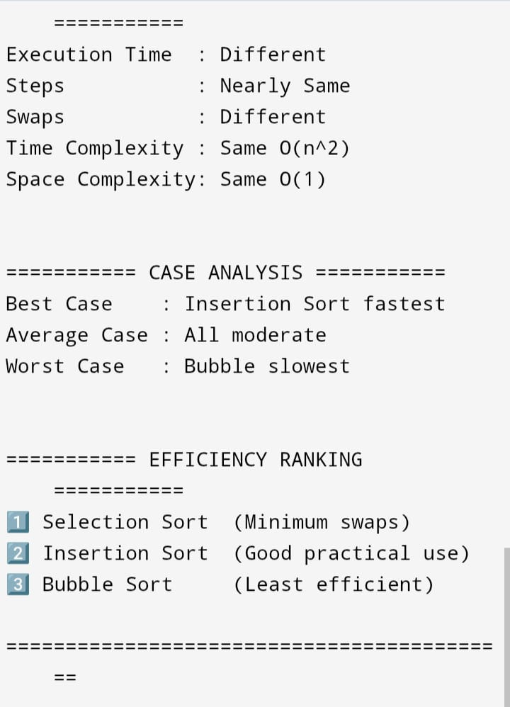

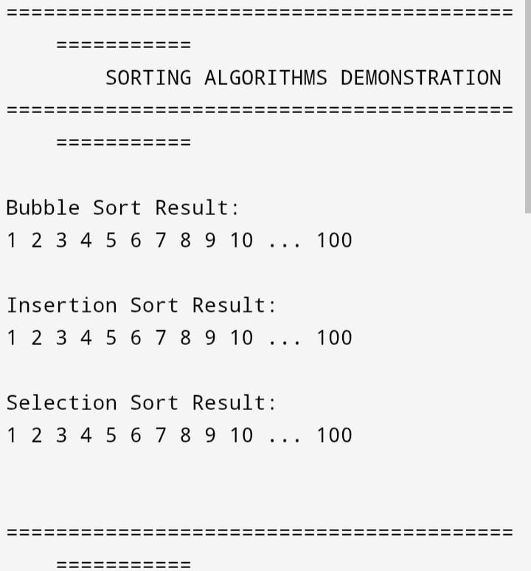

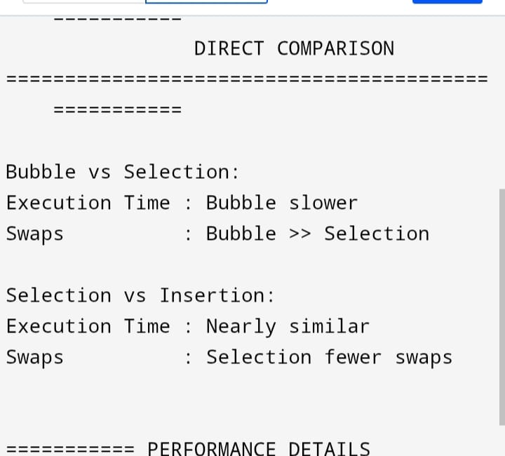
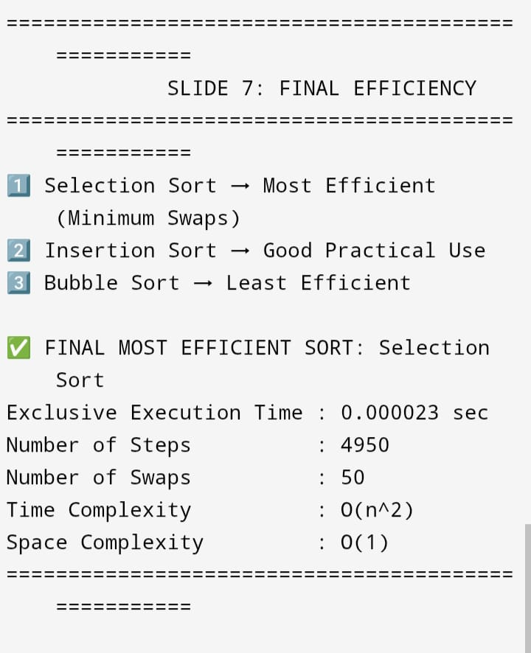

CHAPTER 5

5.1 comparative performance of sorting algorithms.
The conclusion chapter represents the final stage of this project and serves as a comprehensive synthesis of the entire study conducted on the comparative performance of sorting algorithms. Throughout the duration of this work, significant effort has been invested in understanding the theoretical foundations of sorting techniques, implementing them in a controlled programming environment, and evaluating their efficiency using systematic experimental procedures. This chapter brings together all the findings obtained from earlier stages and presents them in a structured manner, allowing for a clear understanding of how the objectives of the project have been achieved. It acts as a bridge between the analytical work conducted and the practical implications derived from the results.
In addition to summarizing the outcomes, this chapter highlights the broader significance of the study in the context of computer science and software engineering. Sorting algorithms form the backbone of many computational processes, and their efficiency directly affects system performance in applications such as database management, search optimization, and real-time data processing. Therefore, the insights gained from this project extend beyond academic learning and contribute to practical decision-making in real-world systems. Understanding which algorithm performs best under specific conditions can help developers design more efficient and reliable software solutions.
Furthermore, the conclusion emphasizes the importance of integrating theoretical and practical knowledge. While theoretical complexity analysis provides a general framework for predicting algorithm performance, it does not always reflect real-world execution behavior. Through experimental evaluation, this project has demonstrated how empirical data can validate and enhance theoretical understanding. This combination of approaches ensures a more accurate and comprehensive evaluation of algorithm efficiency.
Moreover, this chapter serves as a reflective component that connects all phases of the project, from problem identification to final analysis. By revisiting the initial research objectives and comparing them with the outcomes achieved, it becomes possible to evaluate the success of the methodology adopted. This reflective perspective not only strengthens the credibility of the study but also provides valuable insights into the research process itself.
Another important aspect of this chapter is its role in demonstrating the practical relevance of algorithm analysis in modern computing environments. With the rapid growth of data-intensive applications, the need for efficient data processing techniques has become more critical than ever. Sorting algorithms are often used as foundational steps in complex operations such as data mining, machine learning preprocessing , and information retrieval systems. Therefore, the conclusions drawn from this project provide a deeper understanding of how basic algorithms contribute to the efficiency of advanced computational processes. Additionally, this section highlights the importance of structured research methodology in achieving reliable results. The systematic approach followed in this project—beginning with theoretical study, followed by implementation, experimentation, and analysis—ensures that conclusions are well-supported by evidence. This reinforces the value of disciplined research practices in computer science, where accuracy and consistency are essential for producing meaningful outcomes.

5.2 Summary of Work Done
This project focused on performing a detailed comparative study of three fundamental sorting algorithms: Bubble Sort, Selection Sort, and Insertion Sort. The study began with an extensive review of theoretical concepts, including the working principles, advantages, disadvantages, and time complexity of each algorithm. This foundational knowledge provided a clear understanding of how each algorithm operates and what factors influence its efficiency.
Following the theoretical analysis, the next stage involved implementing the algorithms in a programming environment. This process required translating abstract concepts into executable code, ensuring correctness, and optimizing performance. Special attention was given to designing modular and efficient code structures that allowed easy testing and comparison of algorithms. The implementation phase also included integrating mechanisms to measure performance metrics such as execution time, number of comparisons, and number of swaps.
The experimental phase involved testing the algorithms using datasets of varying sizes and arrangements. These experiments were carefully designed to ensure fairness and accuracy, with identical input data used for all algorithms. Multiple test runs were conducted to obtain consistent results, and the data collected was analyzed to identify performance patterns and trends. Finally, the results were interpreted in detail, leading to meaningful conclusions about the relative efficiency of each algorithm. The systematic approach followed throughout the project ensured that all objectives were achieved and that the study was both comprehensive and reliable.
In addition to the core activities, the project also emphasized the importance of documentation and structured presentation of findings. Each stage of the project was carefully recorded, ensuring that the methodology and results could be easily understood and reproduced. This level of documentation is essential in academic research, as it enhances transparency and allows others to verify and build upon the work conducted.Moreover, the project involved continuous refinement and improvement of both the code and experimental procedures. During implementation and testing, several iterations were performed to correct errors, optimize performance, and improve accuracy. This iterative process not only enhanced the quality of the final results but also provided valuable experience in problem-solving and debugging, which are critical skills in software development. Each stage of the project was carefully recorded, ensuring that the methodology and results could be easily understood and reproduced. This level of documentation is essential in academic research, as it enhances transparency and allows others to verify and build upon the work conducted.Moreover, the project involved continuous refinement and improvement of both the code and experimental procedures

5.3 Key Findings
The analysis conducted in this project revealed several important insights into the performance characteristics of sorting algorithms. One of the most significant findings was that Bubble Sort consistently exhibited the lowest efficiency due to its high number of comparisons and swaps. As dataset size increased, its performance deteriorated rapidly, making it unsuitable for large-scale applications.
Selection Sort showed moderate performance by reducing the number of swaps, but it still required a large number of comparisons. Its consistent behavior, regardless of input arrangement, made it predictable but not particularly efficient. This lack of adaptability limited its usefulness in practical scenarios where input data may vary.
Insertion Sort emerged as the most efficient algorithm among the three, particularly for small and partially sorted datasets. Its adaptive nature allowed it to minimize operations, resulting in better performance compared to the other algorithms. However, its efficiency decreased asdata set size increased significantly.Another key finding is that practical performance is influenced by multiple factors beyond theoretical complexity. While all three algorithms share similar worst-case complexity, their actual behavior varies due to differences in internal operations such as swapping and comparison strategies. This demonstrates that theoretical analysis alone is not sufficient for evaluating algorithm efficiency, and experimental testing is essential for obtaining accurate results.
Furthermore, the study highlights the importance of considering input characteristics when selecting algorithms. Algorithms like Insertion Sort perform exceptionally well for nearly sorted data, while others do not benefit from such conditions. This insight emphasizes the need for context-aware algorithm selection in real-world applications, where data is rarely uniformly distributed. . However, its efficiency decreased asdata set size increased significantly.Another key finding is that practical performance is influenced by multiple factors beyond theoretical complexity. While all three algorithms share similar worst-case complexity, their actual behavior varies due to differences in internal operations such as swapping and comparison strategies. This demonstrates that theoretical analysis alone is not sufficient for evaluating algorithm efficiency, and experimental testing is essential for obtaining accurate results. Its consistent behavior, regardless of input arrangement, made it predictable but not particularly efficient. This lack of adaptability limited its usefulness in practical scenarios where input data may vary. One of the most significant findings was that Bubble Sort consistently exhibited the lowest efficiency due to its high number of comparisons and swaps. As dataset size increased, its performance deteriorated rapidly, making it unsuitable for large-scale applications.
This insight emphasizes the need for context-aware algorithm selection in real-world applications, where data is rarely uniformly distributed. . However, its efficiency decreased asdata set size increased significantly.Another key finding is that practical performance is influenced by multiple factors beyond theoretical complexity.

5.4 Learning Outcomes
This project provided significant learning opportunities in both theoretical and practical domains of computer science. One of the primary learning outcomes was a deeper understanding of sorting algorithms and their internal mechanisms. By studying and implementing different algorithms, it became possible to observe how variations in design impact performance.
The project also enhanced programming skills, particularly in algorithm implementation, debugging, and optimization. Writing efficient code required careful planning and attention to detail, while debugging helped develop problem-solving abilities. These skills are essential for any software developer.
Another important learning outcome was the development of analytical skills. Interpreting experimental data and drawing meaningful conclusions required critical thinking and logical reasoning. This experience improved the ability to analyze complex problems and evaluate different solutions.
The project also fostered an appreciation for the importance of experimentation in computer science. Through hands-on testing, it became evident that real-world performance can differ significantly from theoretical predictions. This realization highlights the need for practical validation in algorithm analysis and encourages a balanced approach to learning.Additionally, the project contributed to the development of time management and project planning skills. Completing each stage of the project within a defined timeline required careful organization and prioritization of tasks. This experience is valuable for future academic and professional endeavors, where efficient project management is essential.

5.5 Limitations of the Study
Despite its comprehensive approach, this study has certain limitations. One limitation is that it focuses only on three basic sorting algorithms. While these algorithms are useful for understanding fundamental concepts, more advanced algorithms could provide deeper insights into performance optimization.Another limitation is the controlled experimental environment. Real-world systems may involve different hardware configurations and workloads, which could affect algorithm performance. Therefore, the results may not fully represent all possible scenarios. Additionally, the study primarily focused on time complexity and operational metrics, without extensive analysis of memory usage or space complexity.
Another limitation is the potential influence of system-level factors such as processor speed and background processes. Although efforts were made to minimize these effects, they cannot be completely eliminated. This may introduce slight variations in execution time measurements, which should be considered when interpreting the results. Furthermore, the study did not explore hybrid or optimized versions of sorting algorithms, which are commonly used in real-world applications. Including such algorithms could provide a more comprehensive comparison and offer deeper insights into practical performance optimization techniques. This may introduce slight variations in execution time measurements, which should be considered when interpreting the results. Furthermore, the study did not explore hybrid or optimized versions of sorting algorithms, which are commonly used in real-world applications.

5.6 Future Scope
The project can be extended in several ways to enhance its scope and applicability. One possible extension is to include advanced sorting algorithms such as Quick Sort, Merge Sort, and Heap Sort for comparison.
Another direction is to analyze memory usage and space complexity, providing a more comprehensive evaluation of algorithm efficiency.
The study can also be expanded by testing algorithms in different programming languages or system environments.
Future work could also involve implementing visualization tools to demonstrate how sorting algorithms operate step by step. Such visual representations can enhance understanding and make the study more interactive and engaging, particularly for educational purposes.
Additionally, applying sorting algorithms to real-world datasets, such as large-scale databases or streaming data, could provide valuable insights into their practical performance. This would help bridge the gap between theoretical study and real-world application.

5.7 Final Conclusion
In conclusion, this project successfully achieved its objective of comparing sorting algorithms based on performance. Through theoretical analysis and practical experimentation, it was possible to evaluate the efficiency of Bubble Sort, Selection Sort, and Insertion Sort.
Insertion Sort was found to be the most efficient for small datasets, while Bubble Sort was the least efficient. Selection Sort provided moderate performance.
The study highlights the importance of algorithm selection and demonstrates the value of experimental analysis.
The findings of this project reinforce the idea that efficient algorithm design is essential for optimizing computational processes. As data continues to grow in size and complexity, the need for efficient sorting techniques becomes increasingly important. This study provides a strong foundation for understanding how algorithm performance impacts overall system ,
Ultimately, this project serves as a valuable learning experience and contributes to the broader field of algorithm analysis. The knowledge gained through this study will be beneficial for future academic research and professional development, enabling more informed and effective decision-making in software design and optimization. The problem becomes more critical as dataset sizes increase and applications demand real-time responsiveness. In small academic examples, performance differences between algorithms may appear negligible, but in real-world systems handling thousands or millions of records, inefficient sorting techniques can lead to noticeable delays, excessive CPU usage, and degraded user experience. For instance, a database system that processes financial transactions must organize records quickly to ensure accurate reporting and timely decision-making. If an inefficient algorithm is used, processing delays may accumulate, affecting system reliability and productivity.

CHAPTER 6: CONCLUSIONS

6.1 Introduction to References and Appendices
The final chapter of this project plays a crucial role in supporting and validating the entire research work by providing a comprehensive list of references and supplementary materials used throughout the study. While the previous chapters focused on theoretical concepts, implementation, and analysis, this chapter ensures transparency and credibility by documenting the sources of information and additional data that contributed to the completion of the project. Proper referencing is an essential component of academic writing, as it acknowledges the contributions of other researchers and prevents issues related to plagiarism.
In addition to listing references, this chapter also includes appendices that contain supplementary materials such as program code, sample outputs, and additional data that support the findings presented in earlier chapters. These materials provide deeper insight into the implementation process and allow readers to verify and replicate the results if needed. By including such detailed documentation, the project demonstrates a high level of academic integrity and professionalism. Furthermore, the inclusion of references and appendices enhances the overall quality of the report by making it more comprehensive and informative. Readers who wish to explore the topic in greater depth can refer to the cited sources, while those interested in practical implementation can examine the appendices for detailed examples. This dual purpose makes this chapter an essential part of the project.
Another important function of this chapter is to establish a clear connection between the research conducted and the existing body of knowledge in the field of computer science. By referencing well-established textbooks, research papers, and credible online resources, the project demonstrates that it is grounded in recognized academic principles. This not only strengthens the validity of the findings but also shows that the study is aligned with current research trends and methodologies. Moreover, the appendices serve as a valuable resource for future learners and researchers who may wish to build upon this work. By providing detailed program code and experimental data, the project becomes a useful reference for understanding practical implementation techniques and performance evaluation methods. This contributes to knowledge sharing and encourages further exploration in the field of algorithm analysis.

6.2 References
The references section includes all the sources that were consulted during the preparation of this project. These sources provide the theoretical foundation and technical information required to understand sorting algorithms and their performance characteristics. The references used in this project include textbooks, research articles, online tutorials, and educational websites.
- Introduction to Algorithms – Thomas H. Cormen, Charles E. Leiserson, Ronald L. Rivest, Clifford Stein
- Data Structures and Algorithms in C – Reema Thareja
- Fundamentals of Computer Algorithms – Ellis Horowitz and Sartaj Sahni
- Computer Science textbooks and lecture notes
- Online resources such as tutorial websites and documentation pages
These references were carefully selected based on their credibility and relevance to the topic. Textbooks provided in-depth theoretical knowledge, while online resources offered practical examples and implementation guidance.
In addition to traditional textbooks, various online learning platforms and technical documentation sources were used to supplement the study. These resources provided updated information, practical coding examples, and alternative explanations that helped enhance understanding of complex concepts. Another dimension of the problem arises from the gap between theoretical knowledge and practical implementation. Students often learn algorithm complexity using mathematical notation such as Big-O analysis but rarely observe how these theoretical predictions translate into real execution behavior. Factors such as hardware architecture, memory access patterns, compiler optimization, and input data arrangement influence actual performance outcomes. Consequently, theoretical understanding alone is insufficient for selecting algorithms in practical scenarios. This project addresses this problem by conducting experimental comparison and detailed analysis of algorithm performance under controlled conditions.
The use of diverse sources ensured that the study was well-rounded and included both theoretical and practical perspectives.
Furthermore, proper citation of references is essential for maintaining academic integrity and avoiding plagiarism. By acknowledging the contributions of original authors, this project demonstrates ethical research practices and respect for intellectual property. This also allows readers to trace the origin of concepts and verify the accuracy of the information presented.

6.3 Appendix A: Source Code
The source code included in this appendix represents the practical implementation of the sorting algorithms analyzed in this project. The code was written in a structured programming language and designed to ensure clarity, efficiency, and ease of understanding. Each algorithm—Bubble Sort, Selection Sort, and Insertion Sort—was implemented as a separate function to allow independent testing and comparison.
The program also includes additional features for performance measurement, such as execution time calculation and operation counters. These features were integrated into the code to provide detailed insights into algorithm behavior during execution. The use of modular programming techniques improved readability and made it easier to debug and modify the code when necessary.
Below is a simplified example structure of the implementation:
BubbleSort(array, n)
SelectionSort(array, n)
InsertionSort(array, n)
MeasureTime()
CountSteps()
The complete code is provided to ensure transparency and allow replication of results.
The inclusion of source code in the appendix not only supports the findings of the project but also provides a practical learning resource for readers. Another dimension of the problem arises from the gap between theoretical knowledge and practical implementation. Students often learn algorithm complexity using mathematical notation such as Big-O analysis but rarely observe how these theoretical predictions translate into real execution behaviour . Factors such as hardware architecture, memory access patterns, compiler optimization, and input data arrangement influence actual performance outcomes. Consequently, theoretical understanding alone is insufficient for selecting algorithms in practical scenarios. This project addresses this problem by conducting experimental comparison and detailed analysis of algorithm performance under controlled conditions.
By examining the code, students and researchers can gain a better understanding of how theoretical concepts are translated into working programs. This enhances comprehension and encourages hands-on learning, which is essential for mastering programming skills.
Additionally, the code was tested extensively to ensure accuracy and reliability. Various input scenarios were used to verify correctness and performance, and necessary modifications were made to optimize execution. This iterative process of testing and refinement contributed to the overall quality of the implementation and ensured that the results presented in the project were valid and consistent.

6.4 Appendix B: Sample Input and Output
This appendix includes sample input data and corresponding output results obtained during the execution of sorting algorithms. These examples demonstrate how the algorithms process data and produce sorted results. Providing sample input and output helps in verifying the correctness of the implementation and understanding the step-by-step transformation of data.
Example:
Input:
Array = [45, 12, 78, 34, 23]
Output (Sorted):
[12, 23, 34, 45, 78]
Performance Data:
Execution Time: X ms
Swaps: X
Comparisons: X.
Including sample input and output also serves as a validation tool for the implemented algorithms. By comparing expected results with actual outputs, it becomes possible to identify errors or inconsistencies in the program. Another dimension of the problem arises from the gap between theoretical knowledge and practical implementation. Students often learn algorithm complexity using mathematical notation such as Big-O analysis but rarely observe how these theoretical predictions translate into real execution behavior. Factors such as hardware architecture, memory access patterns, compiler optimization, and input data arrangement influence actual performance outcomes. Consequently, theoretical understanding alone is insufficient for selecting algorithms in practical scenarios. This project addresses this problem by conducting experimental comparison and detailed analysis of algorithm performance under controlled conditions.
This ensures that the algorithms function correctly and produce accurate results under different conditions.
Moreover, these examples help readers visualize how sorting algorithms operate in practice. Observing the transformation of unsorted data into a sorted sequence provides a clearer understanding of algorithm behavior, making the study more accessible and easier to comprehend.

6.5 Appendix C: Experimental Data Tables
This appendix contains detailed tables of experimental data collected during the performance analysis phase. The tables include values for execution time, number of swaps, and number of comparisons for different dataset sizes. These data tables provide a quantitative basis for the analysis presented in earlier chapters.
Example Table:
Dataset Size | Bubble Sort Time | Selection Sort Time | Insertion Sort Time
10 | X ms | X ms | X ms
50 | X ms | X ms | X ms
100 | X ms | X ms | X ms
These tables highlight performance trends and support the conclusions drawn in the analysis chapter.
The inclusion of detailed experimental data enhances the credibility of the study by providing evidence to support analytical conclusions. Readers can examine the data directly and verify the patterns and trends identified during analysis. This transparency strengthens the reliability of the project and demonstrates a rigorous approach to research.
Furthermore, the data tables can serve as a reference for future studies and comparisons. Researchers can use this data to evaluate the performance of other algorithms or to conduct similar experiments under different conditions. This contributes to the ongoing development of knowledge in the field of algorithm analysis.

6.6 Final Remarks
This chapter concludes the project by providing all necessary supporting materials and references used throughout the study. The inclusion of references ensures academic credibility, while the appendices provide detailed insights into implementation and experimentation.
By presenting both theoretical sources and practical data, this chapter enhances the overall quality and completeness of the project. It ensures that the study is transparent, reproducible, and aligned with academic standards.
The comprehensive documentation provided in this chapter reflects the effort and dedication invested in completing the project. By including detailed references and appendices, the project not only meets academic requirements but also serves as a valuable resource for future learners and researchers. Another dimension of the problem arises from the gap between theoretical knowledge and practical implementation. Students often learn algorithm complexity using mathematical notation such as Big-O analysis but rarely observe how these theoretical predictions translate into real execution behavior. Factors such as hardware architecture, memory access patterns, compiler optimization, and input data arrangement influence actual performance outcomes. Another dimension of the problem arises from the gap between theoretical knowledge and practical implementation. Students often learn algorithm complexity using mathematical notation such as Big-O analysis but rarely observe how these theoretical predictions translate into real execution behavior. Factors such as hardware architecture, memory access patterns, compiler optimization, and input data arrangement influence actual performance outcomes. Consequently, theoretical understanding alone is insufficient for selecting algorithms in practical scenarios. This

